T-106.1227 Data Structures and Algorithms
Project Report (Solution Part)
Nan Chen
266035
09.04.2011
Table of Contents
1.Introduction 1
a)General description and aims (orientation, motivation, goals) 1
b)Justification of the library, exclusions if not feasible to evaluate all structures 1
2.Literature survey 1
a)General descriptions of the library 1
b)List of data structure and algorithms 1
c)Working environment 2
d)Evaluation methods (time and space) 2
e)Empirical results of the algorithms 4
f)Comparison with the analytical results 5
List 5
Sorting algorithms 6
AVL Tree 9
3.Discussion 11
a)Conclusions about the feasibility of the library, refer to the results above 11
b)Learning outcome 11
c)Improvement options 12
4.Time consumption 12
5.References 12

Introduction

General description and aims (orientation, motivation, goals)
The project is to create and test the efficiency in terms of time and memory usage of a small C-language library of generic data structures modified from the source code provided by the book <Data Structures and Algorithm Analysis in C (Second Edition, Mark Allen Weiss)>[1]. This small library would not be a business-class comprehensive one, but for academic purposes, by creating it, going through and examining it, a student should obtain detailed knowledge and hands-on experience of general data structures thoroughly. And during the process of the project, student is supposed to form a systematic way of thinking in Data Structures and Algorithms with real implementation issues.

Justification of the library, exclusions if not feasible to evaluate all structures
So far, Linked List, AVL Tree and several Sorting Algorithms have been evaluated. They were chosen as representatives of a branch of similar data structures.

Literature survey

General descriptions of the library
The library has been modified from the source code of <Data Structures and Algorithm Analysis in C (Second Edition, Mark Allen Weiss)>. Basically the modification arranges the source code in a single project by refactoring the structures of the source code, providing a possibility of utilizing the source code as a data structure library. The correctness of algorithms is ensured by the existing testing code. The library code is located at: https://github.com/nanchen/c-data-structures-analysis/tree/master/ds-lib

List of data structure and algorithms
Evaluated data structures are highlighted
Data structure | Operations
List
Linked List | MakeEmpty, IsEmpty, IsLast, Find, Delete, FindPrevious, Insert, DeleteList, Header, First, Advance, Retrieve
Linked List (cursor version) | Same as List
Stack (array version) | IsEmpty, IsFull, CreateStack, DisposeStack, MakeEmpty, Push, Top, Pop, TopAndPop
Stack (list version) | IsEmpty, CreateStack, DisposeStack, MakeEmpty, Push, Top, Pop
Queue | IsEmpty, IsFull, CreateQueue, DisposeQueue, MakeEmpty, Enqueue, Front, Dequeue, FrontAndDequeue
Tree
Tree | MakeEmpty, Find, FindMin, FindMax, Insert, Delete, Retrieve
AVL Tree | MakeEmpty, Find, FindMin, FindMax, Insert, Retrieve
Top-down Splay Tree | MakeEmpty, Find, FindMin, FindMax, Initialize, Insert, Remove, Retrieve
Determinstic Skip List | MakeEmpty, Find, FindMin, FindMax, Initialize, Insert, Remove, Retrieve
Top-down Red Black Tree | MakeEmpty, Find, FindMin, FindMax, Initialize, Insert, Remove, Retrieve, PrintTree
Treap | MakeEmpty, Find, FindMin, FindMax, Initialize, Insert, Remove, Retrieve
AA Tree | MakeEmpty, Find, FindMin, FindMax, Initialize, Insert, Remove, Retrieve
K-D Tree | RecursiveInsert, RecPrintRange
Hash Table
Hash Table(separate chaining) | InitializeTable, DestroyTable, Find, Insert, Retrieve
Hash Table (quadratic probing) | InitializeTable, DestroyTable, Find, Insert, Retrieve, Rehash
Heap
Binary Heap | Initialize, Destroy, MakeEmpty, Insert, DeleteMin, FindMin, IsEmpty, IsFull
Leftist Heap | Initialize, FindMin, IsEmpty, Merge, Insert, DeleteMin
Pairing Heap | Initialize, Destroy, MakeEmpty, Insert, DeleteMin, FindMin, DecreaseKey, IsEmpty, IsFull
Sorting
Sorting Algorithms | InsertionSort, Shellsort, Heapsort, Mergesort, Quicksort
Other
Disjoint Set | Initialize, SetUnion, Find

Working environment
ubuntu 10.10, gnu plot, gcc, eclipse, codeblocks, github.com, git scm

Evaluation methods (time and space)
Originally for time measurement it was planned to use “clock_t clock(void)” method provided by C standard library, but it has been found on Linux(Ubuntu 10.10 32-bit) the minimal unit is 10 ms. Thus the accuracy of this approach would be poor unless large input size per test is used. The left figure below illustrates the inaccuracy with small input sizes. In order to have acceptable accuracy, the input size must be larger, time used must be longer, as the right figure below shows

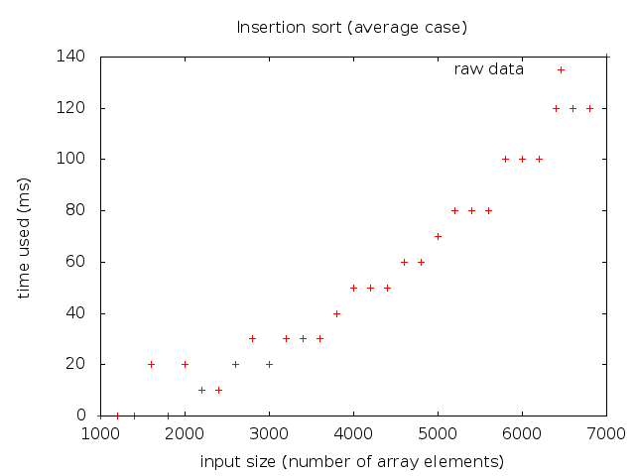
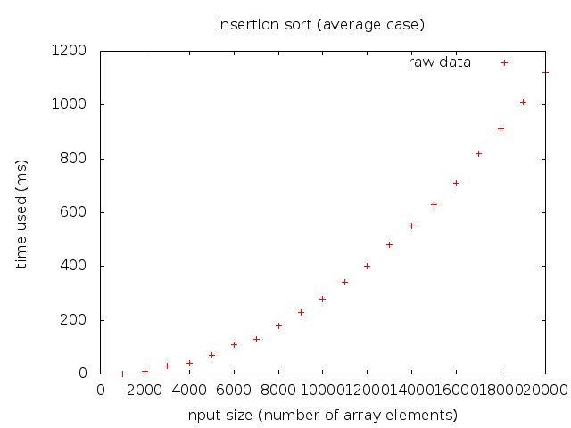
Therefore, In this project, for recording time/space consumption, I mainly use a method of “embedding code” to achieve fine-grained measurement unit of time & space. On the other hand, the real time measurement (using “clock_t clock(void)”) is also supported by the measurement module.
A time/space measurement module is provided to log the time/space consumption, then in the source code of algorithms, the logTime() and logSpace() functions are called from appropriate places to record time/space usage.
For example in the following code snippet of insertion sort, corresponding stack space and time usage are logged, later on, will be used in analysis. Here I count all kinds of computations as “1 step” including addition, subtraction, multiplication, division, assignment, array index operations, pointer operations, entering / exiting function, etc.
Although those operations take quite different computation resources when computer really performs them, here for the purpose of algorithm analysis, this extra precision is not significant since for large enough inputs, the multiplicative constants are dominated by the effects of the input size itself [2].
As for space usage logging, not only the stack memory usage is recorded, the heap memory allocation/deallocation (malloc/free) is also recorded correspondingly.
void insertionSort(ElementType A[], int N) {
//--------------space------------------------------
const int SPACE = sizeof(ElementType) + sizeof(int);
Resource_logSpace(SPACE); // log the stack space
//--------------space------end---------------------
int j, P; // time = 2
ElementType Tmp; // time = 1
for (P = 1; P < N; P++) { // time = 3
Tmp = A[P]; // time = 2
for (j = P; j > 0 && A[j - 1] > Tmp; j--) { // time = 7
A[j] = A[j - 1]; // time = 4
Resource_logTime(11); // 7 steps in for loop, 4 steps of retriving data from array & assign
}
A[j] = Tmp; // time = 2
Resource_logTime(7); // log the time spent in this basic block (for loop)
}
Resource_logTime(5); // log the time outside of the for loop, including entering / exiting function cost
Resource_logSpace(-SPACE); //log the deallocation of stack space when returning
}
In the complexity test, I execute the operations with different input sizes (e.g. from 10 to 1000 step = 10). After the execution of test, all the time/space usage for each different input size has been recorded, an analysis is executed to evaluate the time/space complexity of the operation. It performs the duty as the following:
- Calculate “constant” for common complexity classes (currently:it could be easily extended to support other complexity classes) for each input size
e.g for , I calculate as: constant = for each N
- Calculate the arithmetic mean (mean = ) of constant for all the input sizes
- Calculate the “Relative Standard Deviation” (RSD hereinafter) for each complexity class, choose the one with minimal RSD as the determined complexity class.
RSD =
- Draw the raw data and determined function on screen and compare them.
Refer to an approach with similar idea presented in sector 2.4.6 of [1]

Empirical results of the algorithms
Conflicting results are highlighted, see the comparison of shell sort below for reasons
Operation | Empirical time | Time RSD | Analytical time | Empirical space | Space RSD | Analytical space
List
List_makeEmpty | Time(N) = 4.10 * N | 5.42% | O(N) | Space(N) = -7.96 * N | 1.17% | O(N)
List_isEmpty | Time(N) = 4.00 |  | O(1) | Space(N) = 4.00 |  | O(1)
List_isLast | Time(N) = 4.00 |  | O(1) | Space(N) = 8.00 |  | O(1)
List_find-(worst-case) | Time(N) = 2.05 * N | 5.14% | O(N) | Space(N) = 8.00 |  | O(1)
List_delete | Time(N) = 27.00 |  | O(1) | Space(N) = -8.00 |  | O(1)
List_findPrevious-(worst-case) | Time(N) = 10.00 |  | O(1) | Space(N) = 8.00 |  | O(1)
List_insert-(onto-first) | Time(N) = 14.00 |  | O(1) | Space(N) = 20.00 |  | O(1)
List_deleteList | Time(N) = 4.05 * N | 2.60% | O(N) | Space(N) = -8.00 * N | 0.00% | O(N)
List_header | Time(N) = 2.00 |  | O(1) | Space(N) = 4.00 |  | O(1)
List_first | Time(N) = 3.00 |  | O(1) | Space(N) = 4.00 |  | O(1)
List_advance | Time(N) = 3.00 |  | O(1) | Space(N) = 4.00 |  | O(1)
List_retrieve | Time(N) = 3.00 |  | O(1) | Space(N) = 4.00 |  | O(1)
Sort
insertion-sort-(average-case) | Time(N) = 2.80 * N^2 | 6.61% | O(N^2) | Space(N) = 8.00 |  | O(1)
insertion-sort-(best-case) | Time(N) = 6.99 * N | 0.33% | O(N) | Space(N) = 8.00 |  | O(1)
insertion-sort-(worst-case) | Time(N) = 5.51 * N^2 | 0.28% | O(N^2) | Space(N) = 8.00 |  | O(1)
heap-sort-(average-case) | Time(N) = 13.65 * NlogN | 1.23% | O(N * logN) | Space(N) = 20.00 |  | O(1)
merge-sort-(average-case) | Time(N) = 23.38 * NlogN | 2.32% | O(N * logN) | Space(N) = 4.71 * N | 24.24% | O(N)
quick-sort-(average-case) | Time(N) = 8.16 * NlogN | 6.45% | O(N * logN) | Space(N) = 20.99 * logN | 8.40% | O(logN)
shell-sort-(average-case) | Time(N) = 13.63 * NlogN | 10.91% | o(N^2) | Space(N) = 8.00 |  | O(1)
AVLTree
insert | Time(N) = 49.35 * logN | 13.17% | O(logN) | Space(N) = 12.28 * logN | 7.77% | O(logN)
make-empty | Time(N) = 9.00 * N | 0.05% | O(N) | Space(N) = -16.00 * N | 0.00% | O(N)
find | Time(N) = 7.99 * logN | 9.77% | O(logN) | Space(N) = 8.00 |  | O(1)
find-min | Time(N) = 6.24 * logN | 6.65% | O(logN) | Space(N) = 4.00 |  | O(1)
find-max | Time(N) = 2.69 * logN | 5.86% | O(logN) | Space(N) = 4.00 |  | O(1)
retrieve | Time(N) = 3.00 |  | O(1) | Space(N) = 4.00 |  | O(1)

Comparison with the analytical results
All the experimental points are plotted in diagram, then a “regression” function line/curve is plotted for comparison

List
MakeEmpty, find (worst case: try to find the last element) & deleteList take linear time
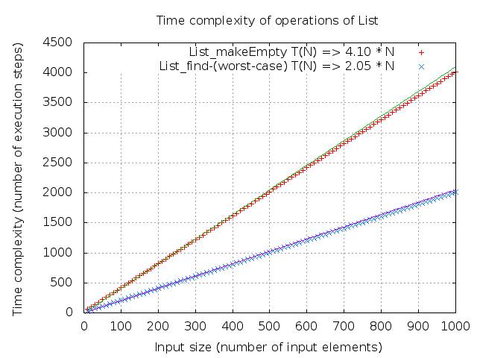
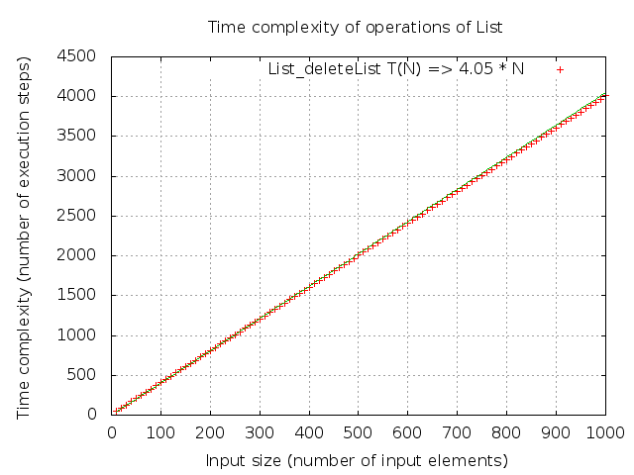
isEmpty, isLast, delete, findPrevious, insert, header, advance & retrieve all take constant time; makeEmpty frees linear space
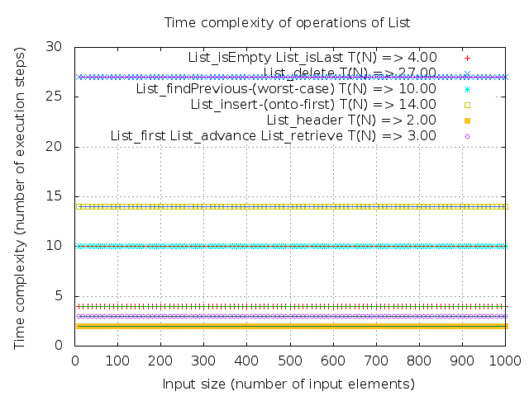
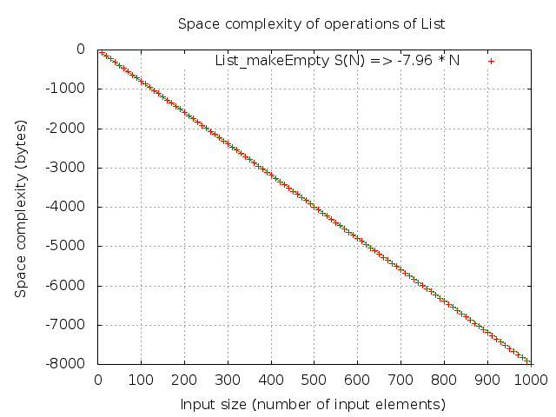
deleteList frees linear space; isEmpty, header, first, find, findPrevious, delete, insert all consume / free constant space
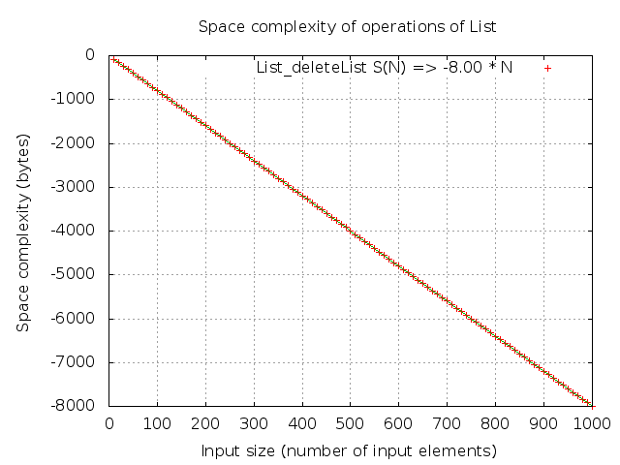
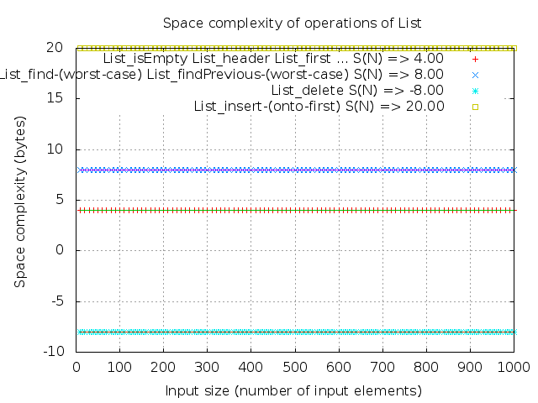

Sorting algorithms
Insertion sort in average / worst cases takes quadratic time
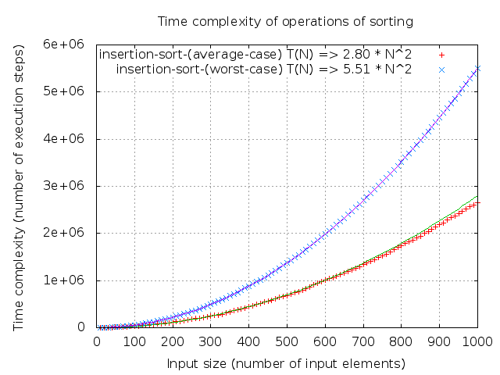

Insertion in best case (input array is already sorted) takes linear time
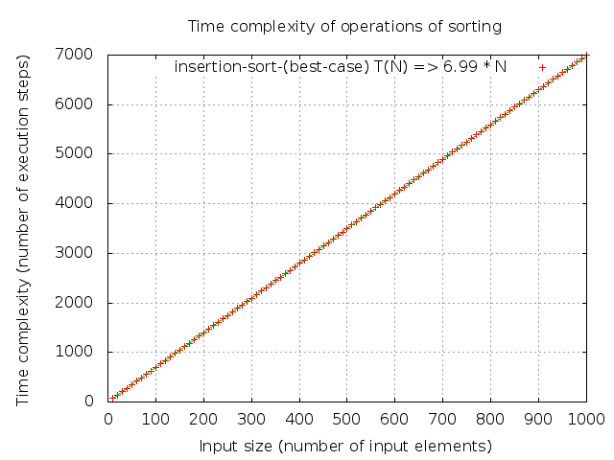

Heap sort, merge sort, quick sort take N*logN time
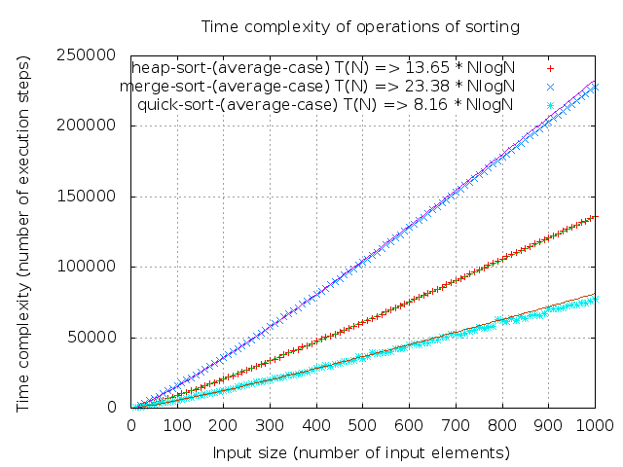

Conflicting result
The analytical time complexity for shell-sort is o(N^2), Here the determined complexity is NlogN, it is because most of the points are along with the 13.63 N*logN curve, as the “o” notation implies that the bound is not tight. It could easily be seen there are some points above the curve at distance. It conforms to the analysis of shell sort in chapter 6 of [1].

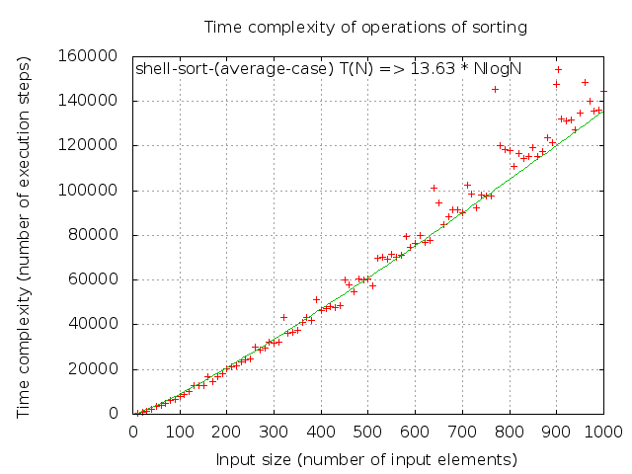

insertion sort (average case, worst case, best case), shell sort, heap sort all consume constant space; Merge sort consumes linear space (since the regression line is not precisely along with the points, maybe the space complexity of average- case merge sort should be of another class which is not so different than O(N), although the worst-case complexity should be O(N) )
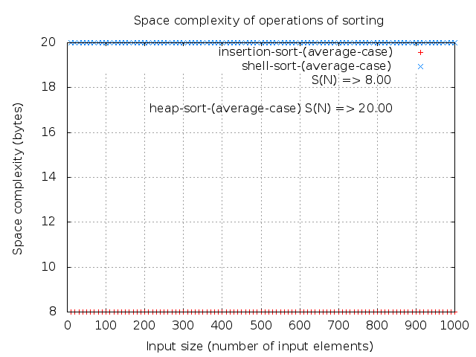
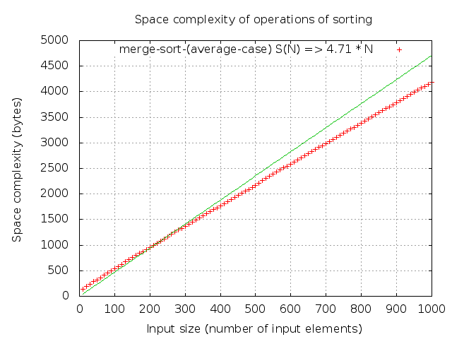
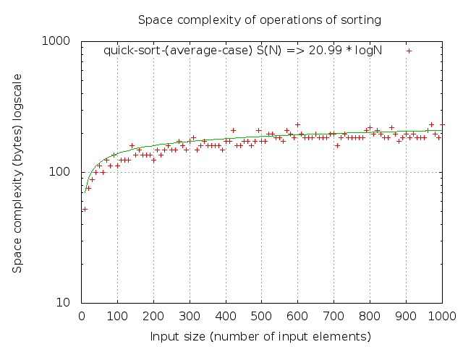
Quick sort consumes logarithmic space

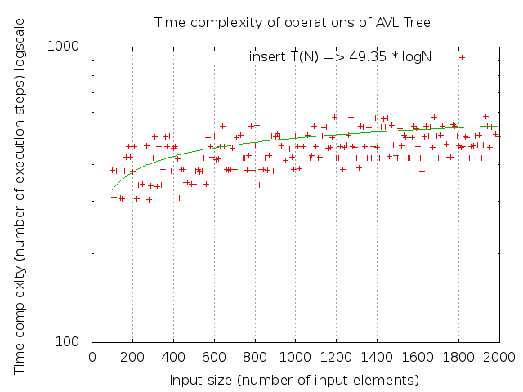
AVL Tree
Insert takes logarithmic time, although the distribution of points is sparse(RSD = 13.17%), it could be seen the points are distributed near the curve

find takes logarithmic time
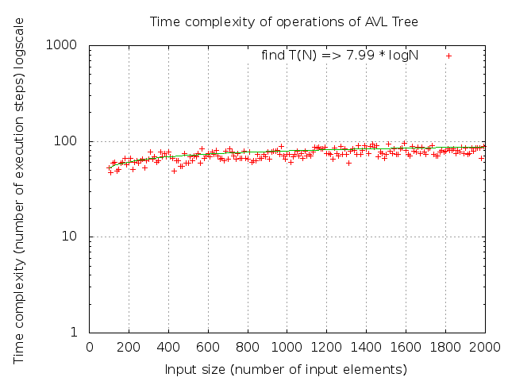

findMin and findMax take logarithmic time, there are some obvious “steps” on the diagram. It is because of some discrete depth differences of the min/max value with different input sizes when finding min / max
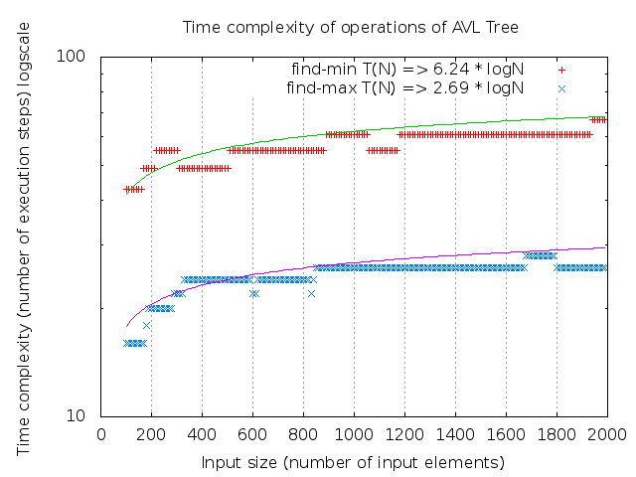
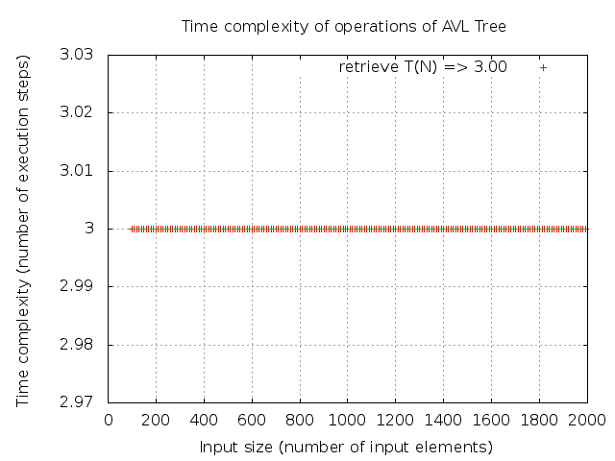
makeEmpty takes linear time; retrieve takes constant time
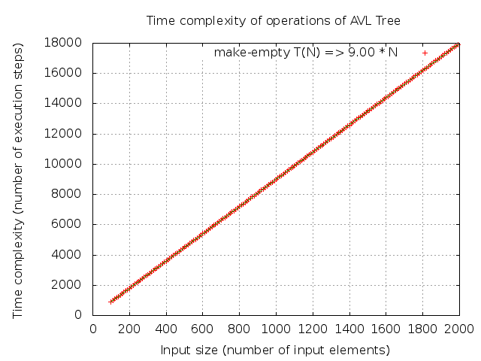

find, findMin, findMax all consume constant space; makeEmpty frees linear space
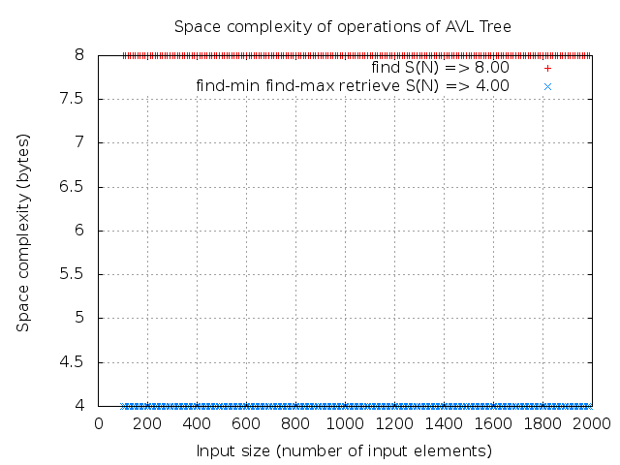
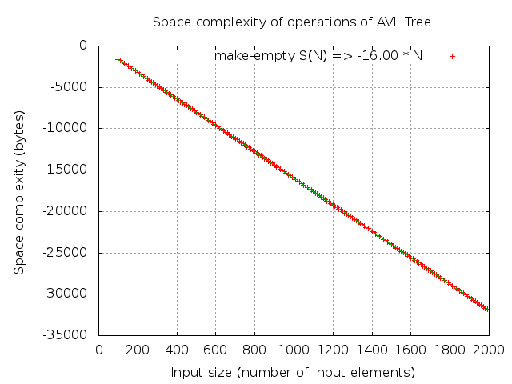

Insert consumes logarithmic space
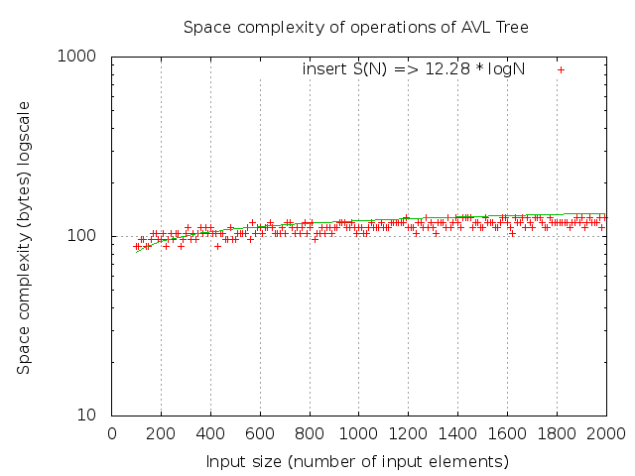

Discussion

Conclusions about the feasibility of the library, refer to the results above
The library provides functionality of basic data structures. It has same empirical complexity results with analytical ones on tested data structures and operations. Actually I am planning to publish an open-source data structure library based on it, targeting on embedded-system C development. Although it is still not a “business-class” library, I believe it has academic values.

Learning outcome
    - Obtained better understanding of algorithm complexity, deeper knowledge of algorithm implementation
    - Created a feasible automated method to analyze the complexity class of algorithms

Improvement options
    - Improve the analysis
    - Test 1-2 more data structures, preferrably Hash Table and/or Priority Queue
    - Improve the feasibility of the library.

Time consumption
Week | Duration | Hours | Phase | Content
Defining Part
9 | 28.02 – 04.03 | 9.71 | Defining | Read the requirements, found a library to evaluate, investigated some measurement methods, wrote this report
Solution Part
10 | 07.03 – 13.03 | 12 | Finding test method | Find solutions to test time/memory use, verify the solutions with one data structure
11 | 14.03 – 20.03 | 8 | Creating library | Modify the source code, create the library containing basic data structures
12 | 21.03 – 27.03 | 21.5 | Running test | Write all tests and run them
13 | 28.03 – 03.04 | 35 | Analysis | Analyze the test results, modify test code if needed
14 | 04.04 – 10.04 | 21 | Report | Write the report
Final Version
15 - 19 | 11.04 – 10.05 | 20 | Final | Improve according to feedback
Total |  | 127.21

Work and time consumption log:
28.02 21:00 – 23:59 2 hours Read the assignment requirements
03.02 18:00 – 22:15 4.25 hours Evaluate libraries, investigate on measurement methods
04.03 17:32 – 19:45 2.21 hours Write defining part report
04.03 20:20 – 21:35 1.25 hours Finalize report and submit
09.03 8 hours Investigate on time/space measurement method
10.03 4 hours Determine to use “embedding code” method, analyze on real-time measurement drawbacks
15.03 8 hours Refactore existing source code into one project to create the library
22.03 8.5 hours Refactore library, develop time/space measurement module
23.03 5 hours Develop measurement module
24.03 8 hours Develop measurement module, call logTime & logSpace from list, test list.
29.03 7.5 hours Develop GNU plot script, improve measurement module
30.03 6 hours Test sorting algorithms, improve measurement module
31.03 7 hours Improve measurement module,
01.04 6.5 hours Test AVLTree, improve measurement module
02.04 8 hours Improve all the tests, analyse the results
04.04 6.5 hours Improve embedded logging code
05.04 6.5 hours Write report, improve code
09.04 8 hours Write report

References
Homepage on github: https://github.com/nanchen/c-data-structures-analysis
Experimental data: https://github.com/nanchen/c-data-structures-analysis/tree/master/plot
[1] Mark A. Weiss. Data Structures and Algorithm Analysis in C (Second Edition) Published by Addison-Wesley, 1997 ISBN: 0-201-49840-5
[2] Thomas H. Cormen, Charles E. Leiserson, Ronald L. Rivest and Clifford Stein. Introduction to Algorithms, Second Edition. Published by MIT press, September 2001, ISBN-10: 0-262-53196-8

